This is the first time I use Joomdle, I followed the document and configured the settings. I want to make the front end look just like your demo shows. But I can't and I may need some help.
- Here is what I set at the back-end. I set open moodle links in “wrapper”.
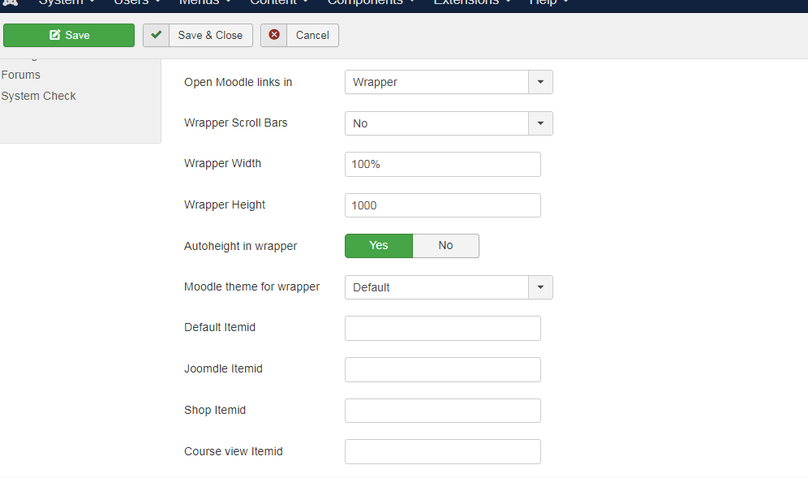
(What does "Default Itemid" and "Course Itemid" mean?)

In moodle, I set "allow theme changes in the URL".
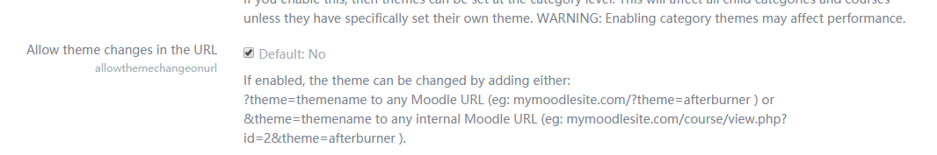

At the front end, when I click “My course” menu; it shows like this. It doesn't show anything... I don't know why it look like this. How to fix it?

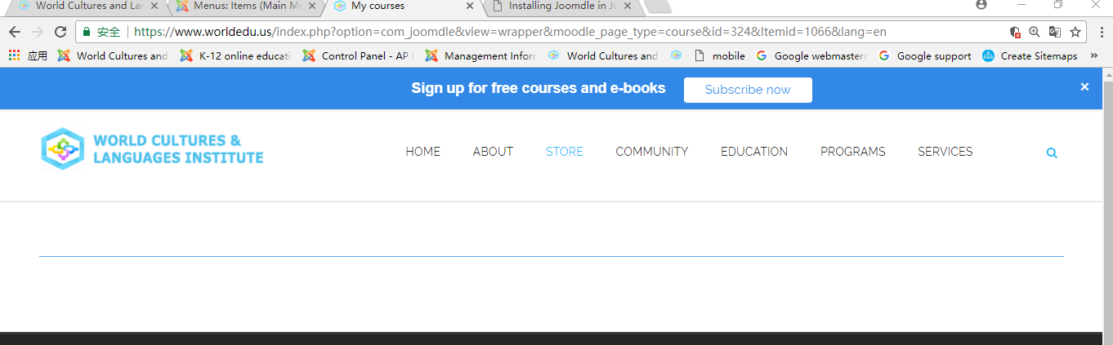

- In addition, what does that "warning" mean? It showed at the front end.
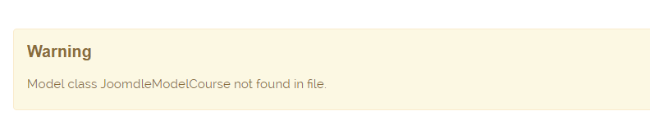

- I want to achieve the layout as your demo shows. Does it relate to the Joomla template?
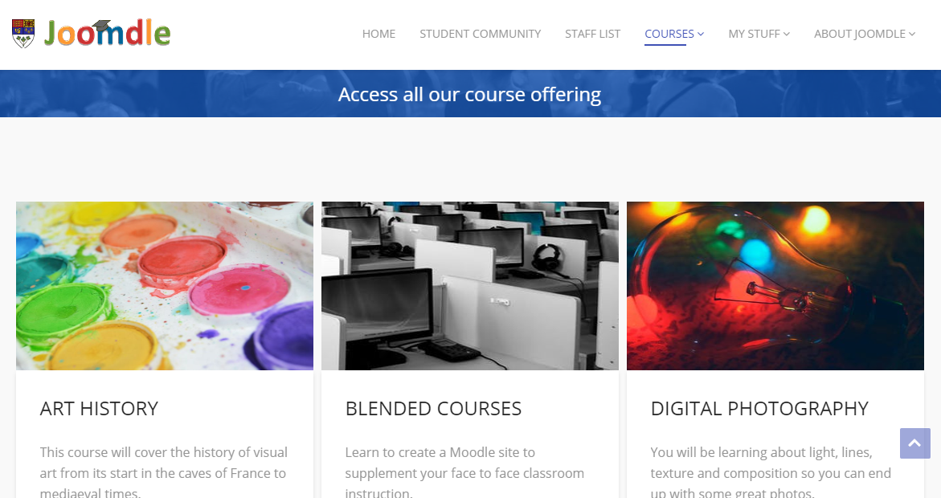
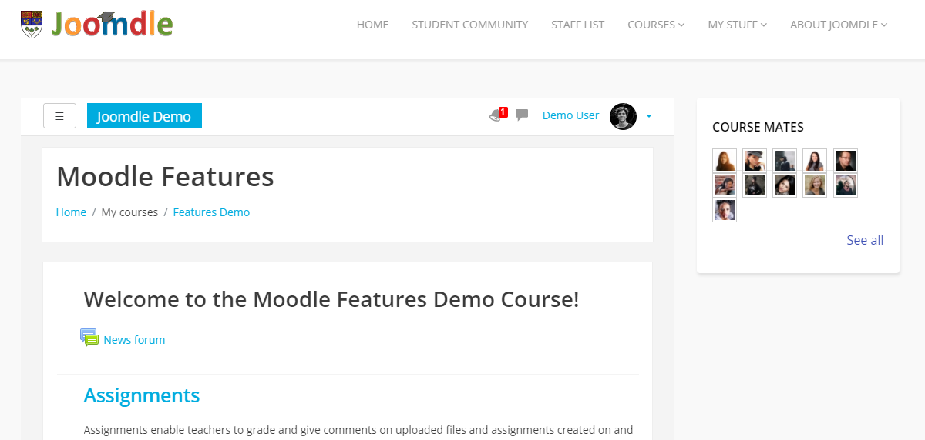

All my looks like this.
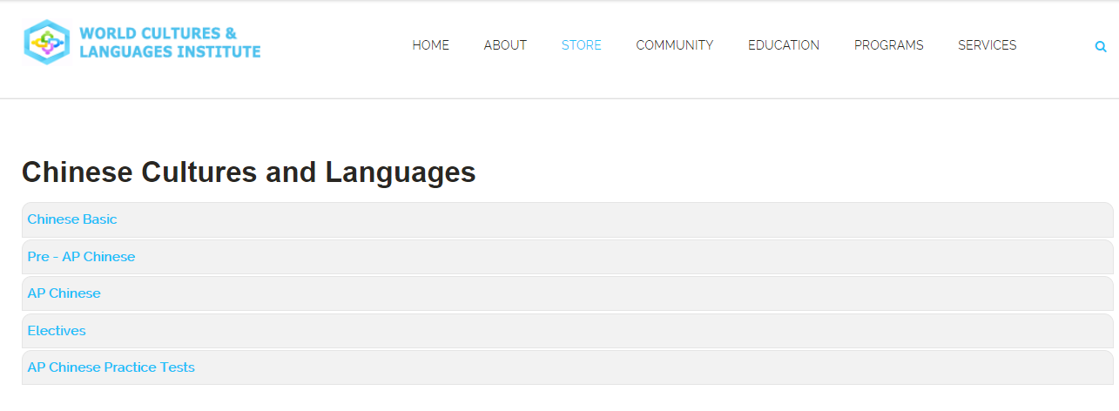

- I want to achieve “Easysocial given points”, I installed the plugin, and enable “give points” in moodle. The document said I need to add the rules to Easysocial. I don’t know how and where to add. Can you show me how to achieve “Give points” in Easysocial?

Here is how I set the menu item.
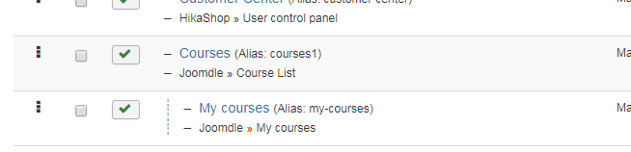

This is our website: https://www.worldedu.us/stores/courses1
The Username and password for test user at the front end: Sandra 19950307

Hope to get your reply. Thank you.

